

Faculty of Computer Science and Engineering

CSEN 701

Embedded Systems

Project

By:

**Name: Ahmed Yasser Elgohary Hanafy**

**ID: 43-2906**

**Tutorial: T-21**

**Name: Omar Emad Mahmoud Elbaroudy**

**ID: 43-2208**

**Tutorial: T-21**

**Name: Ahmed Medhat Abdelhamid**

**ID: 43-3052**

**Tutorial: T-18**

**Name: Omar Sameh Ali Abouhegaziah**

**ID: 43-1931**

**Tutorial: T-18**

**Name: Omar Hany Mohamed**

**ID: 43-5802**

**Tutorial: T-18**

TABLE OF CONTENTS

Brief description 1

Components 2-3

full circuit 4

libraries 5

inputs 6

outputs 7

tasks and prioritization 8

limitations 9

work division 10

**Brief description:**

Every great car started with a prototype. In this report we are going to describe our car prototype which has a lot of features such as an mp3 player with a touch screen that control it, lane keeping assistance, auto adapting lights and a screen displaying the gearbox.

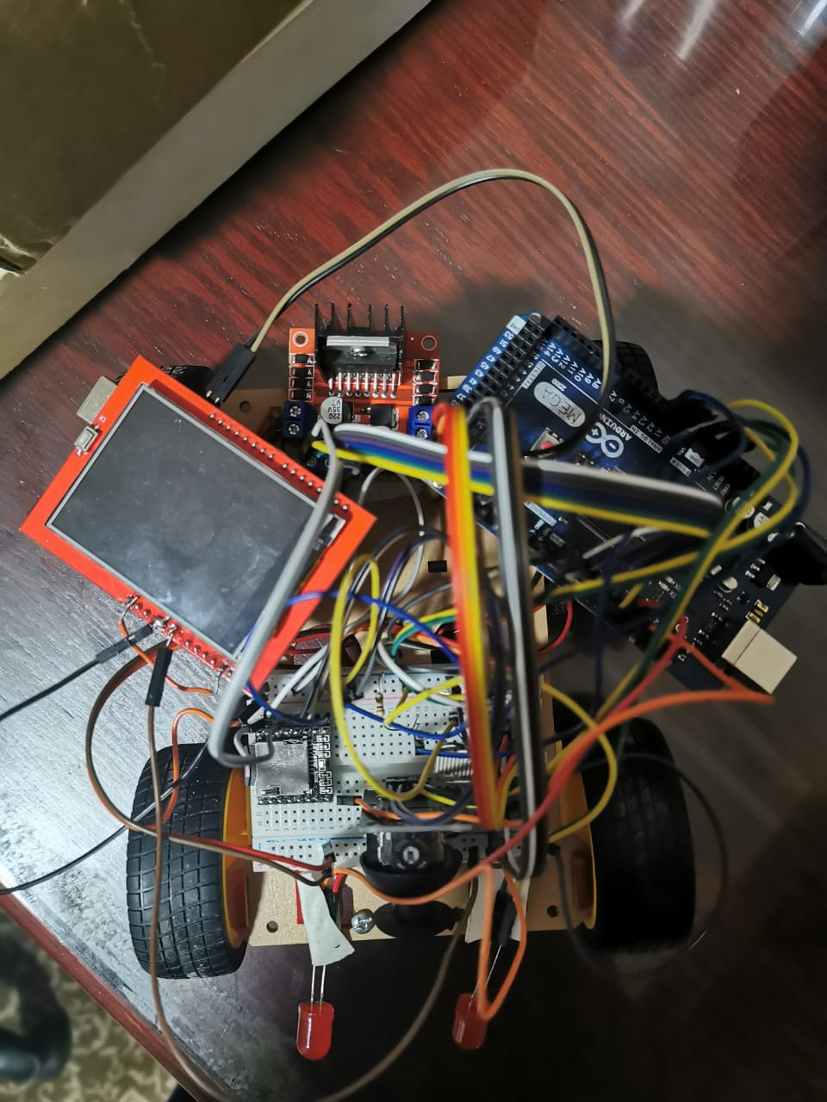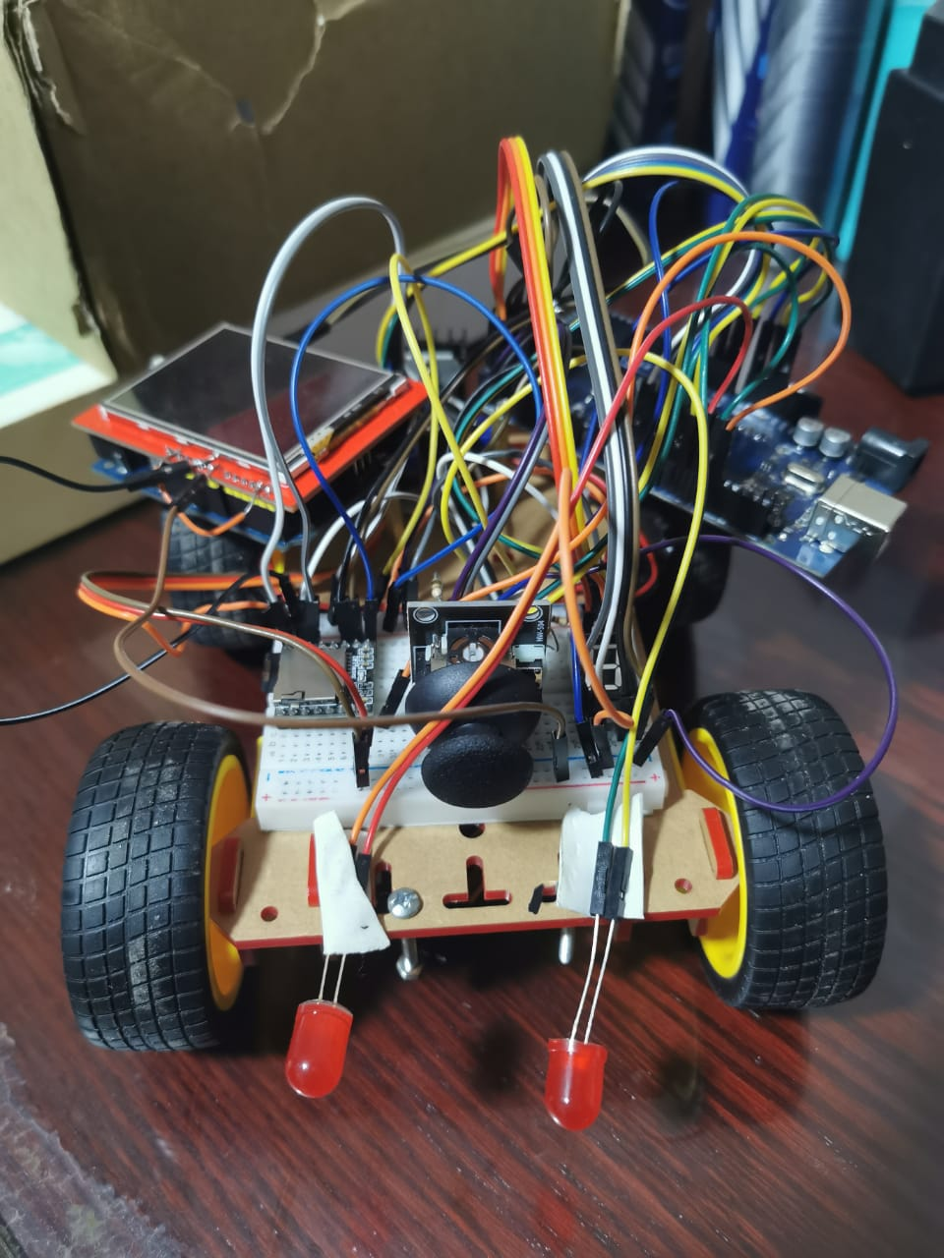We are also going to tackle this prototype inputs, outputs, the prototype full circuit, the prototype’s components and libraries, tasks and last but not least our team’s contribution.

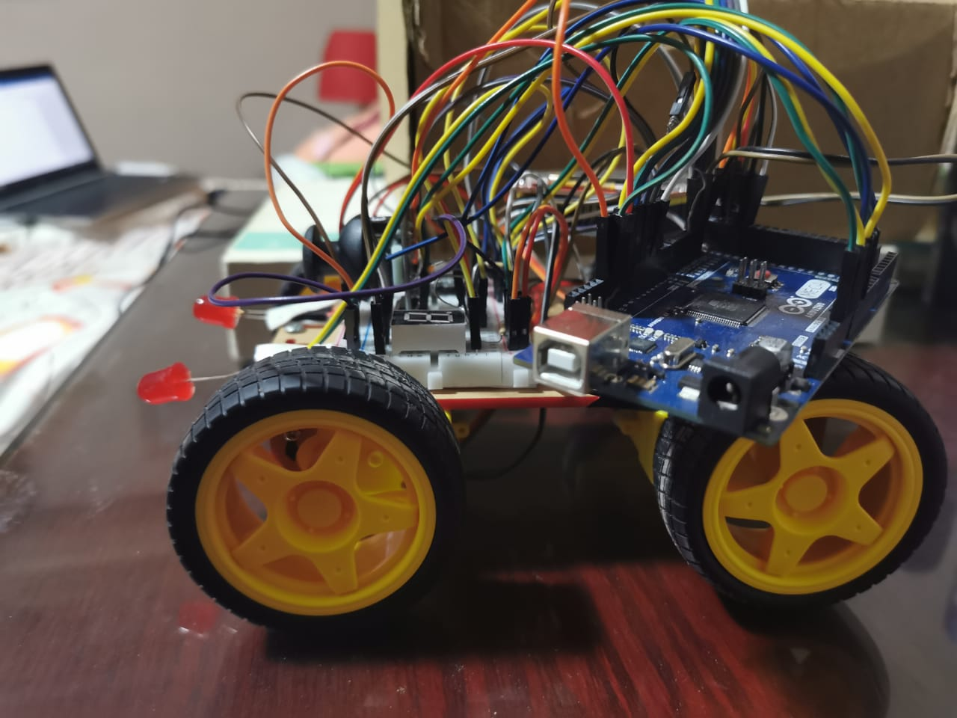

**Components:**

|  |  |  |  |  |
| --- | --- | --- | --- | --- |
| Component | Functionality | Number | Link | Price |
| Robot Kit | The car body including Dc motors | X1 | https://ram-e-shop.com/product/ro-base-dg008/ | 275 |
| Line Follower Sensor | To detect the line | X2 | https://ram-e-shop.com/product/kit-line-track-x1/ | 30x2 |
| Arduino Mega | Control all the tasks | X1 | https://ram-e-shop.com/product/kit-arduino-mega2560/ | 250 |
| Arduino Uno | Control the touchscreen | X1 | https://ram-e-shop.com/product/kit-arduino-uno/ | 135 |
| Joystick Module | Act as the gear box | X1 | https://ram-e-shop.com/product/sf9032/ | 35 |
| LDR sensor | Measure light intensity to control car lights | X2 | https://ram-e-shop.com/product/ldr-mid-12mm/ | 7x2 |
| LEDS 10mm | Act as the car lights | X1 | https://ram-e-shop.com/product/led-pack-10mm/ | 30 |
| LCD TFT 2.4 With Touch Screen | Touch screen to control the mp3 | X1 | https://ram-e-shop.com/product/kit-lcd-tft2-4-ts/ | 175 |
| Motor Driver L298 module | Control the Dc motors | X1 | https://ram-e-shop.com/product/kit-l298-red/ | 60 |
| MP3 Player | Control the speakers and read the SD card | X1 | https://ram-e-shop.com/product/kit-mp3-m87/ | 100 |
| Seven Segment | Display the gear | X2 | https://ram-e-shop.com/product/7s0-5a/ | 3.5x2 |
| Female long pinheaders | connector | X10 | https://ram-e-shop.com/product/ph50-1x8-female-long/ | 2.5x10 |
| Long pinheaders | To replace the LCD pin headers in case needed | X10 | https://ram-e-shop.com/product/ph10-1x40-male/ | 2.5x10 |
| Male Male wires pack | connector | X2 | https://ram-e-shop.com/product/ph61-mm-20cm/ | 22x2 |
| Female Female wires pack | connector | X1 | https://ram-e-shop.com/product/ph62-ff-20cm/ | 22 |
| Female Male wires pack | connector | X1 | https://ram-e-shop.com/product/ph60-mf-20cm/ | 22 |
| Speaker | Play songs | X1 | https://ram-e-shop.com/product/sp-mp4/ | 5 |
| Lithium Rechargeable Battery 18650 / 3.7V | Supply power to the circuit | X4 | https://ram-e-shop.com/product/battery-18650-1100/ | 3x35 |
| Battery holder | Holds the battery | X2 | https://ram-e-shop.com/product/battery-holder-18650x2/ | 2x8 |
| buzzer | Alert when leaving the lane | X1 | https://ram-e-shop.com/product/buzzar6v/ | 5 |
| SD card | Store songs | X1 | Bought offline | 80 |
| Total |  |  |  | 1489LE |

**Full circuit:**

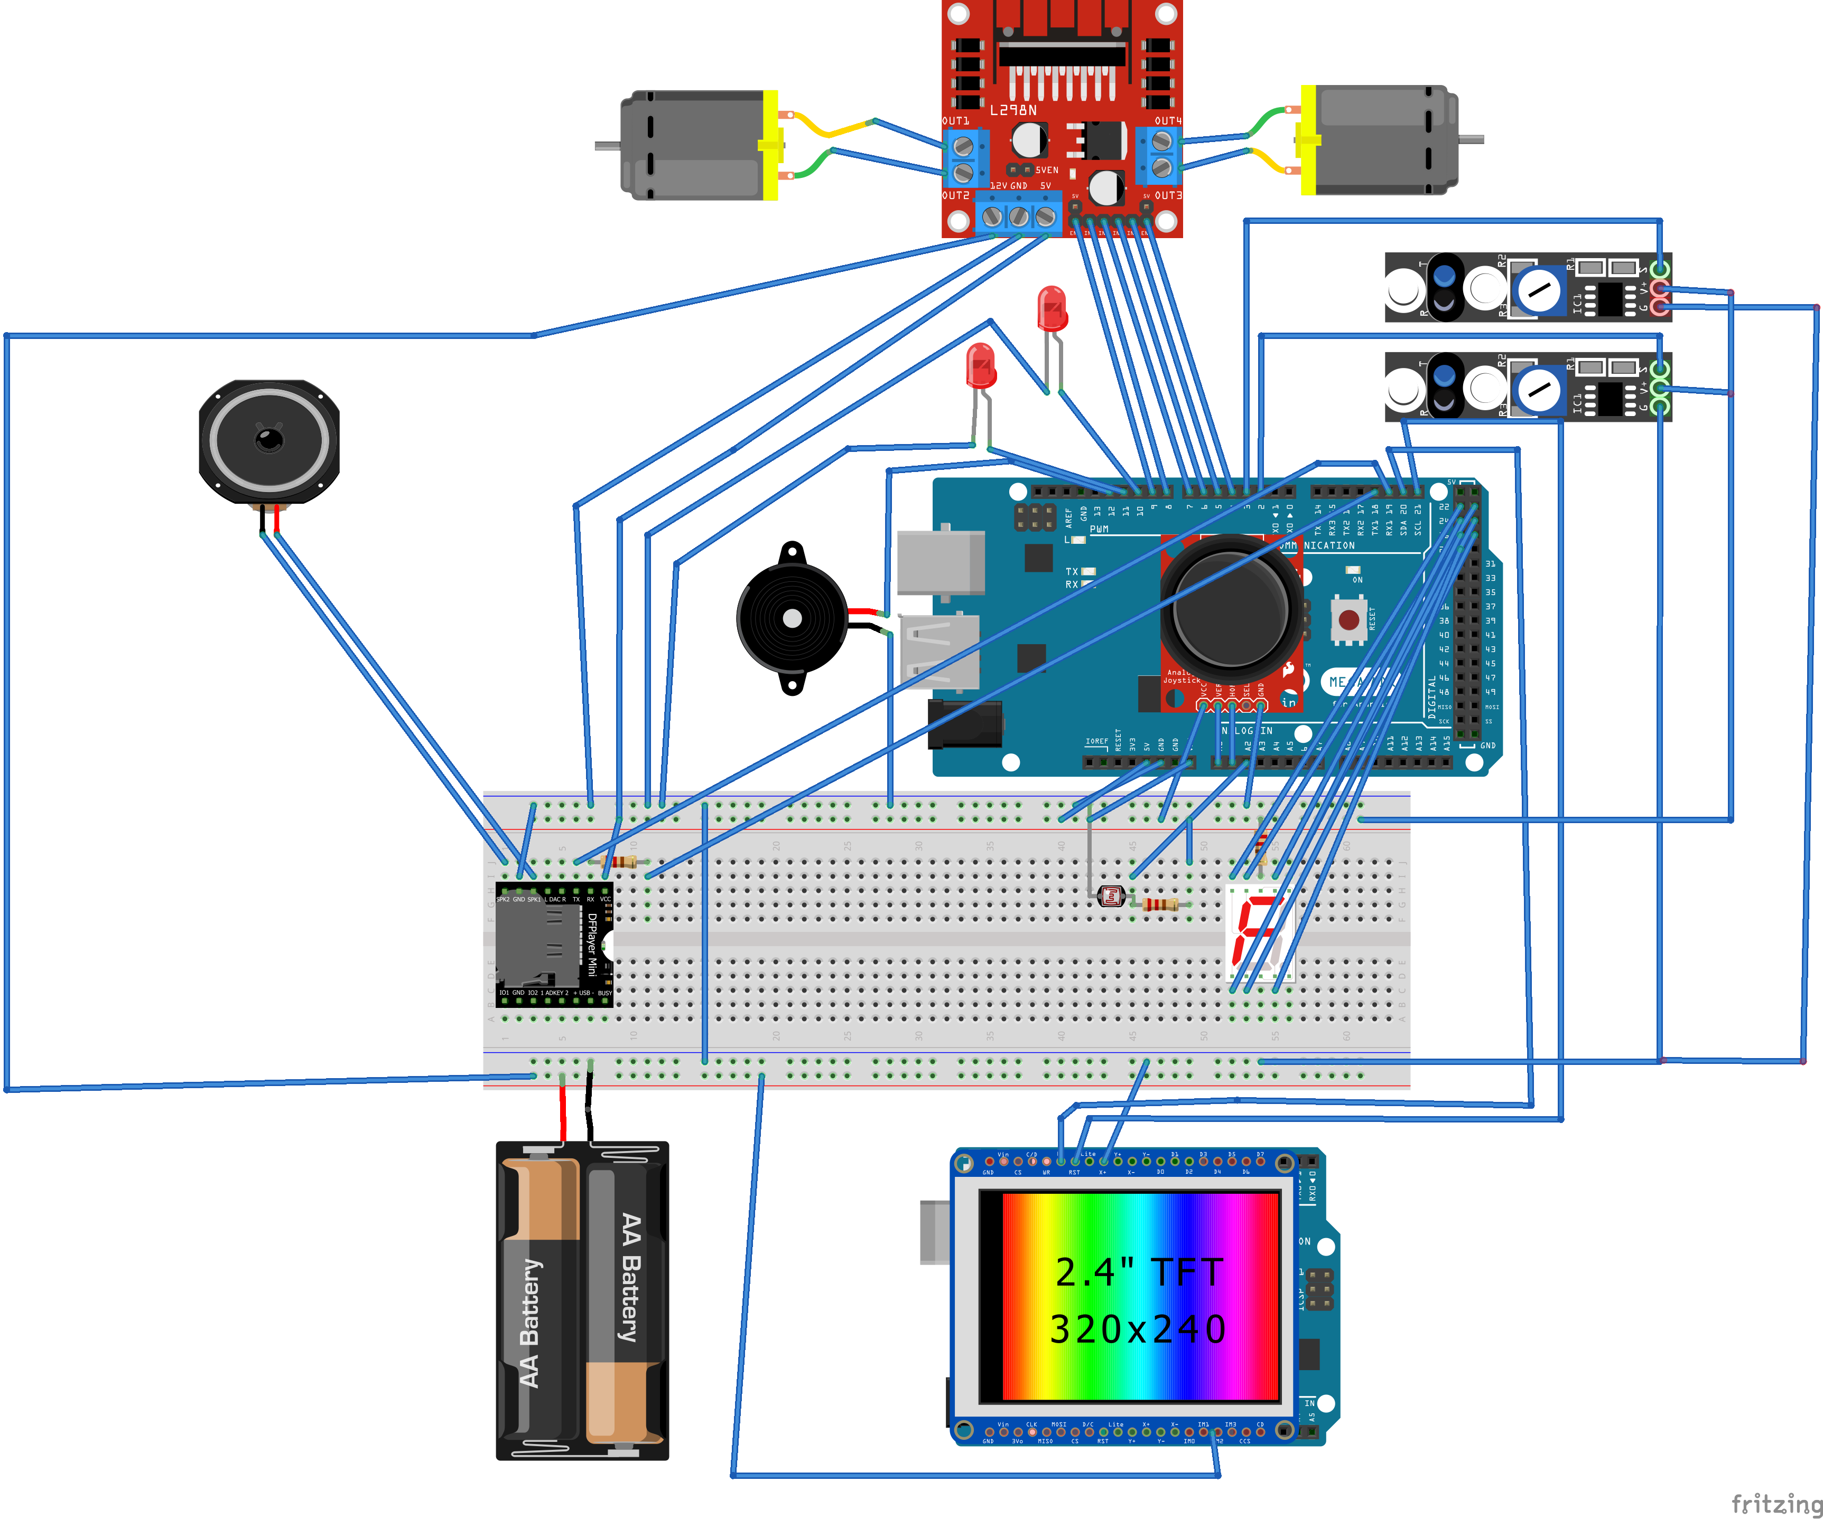

**Libraries:**

|  |  |
| --- | --- |
| Library | Functionality |
| DFRobotDFPlayerMini | Control the mp3 module |
| Wire | Perform the i2c communication between the main mega Arduino which the master and the uno Arduino which is the slave |
| TftSpfd5408 | Control the TFT LCD visuals |
| TouchScreen | Control the TFT LCD touch |
| FreeRTOS | Schedule the tasks |

**Inputs:**

|  |  |
| --- | --- |
| Input | Handling |
| 2 Track sensors | Connected to pin 2 and 3 in the Arduino mega and read digitally every loop |
| LDR circuit output | Connected to pin A2 and read as an analog signal |
| Joystick 2 outputs | Joystick outputs which are x and y coordinates are connected to A0 and A1 and read as an analog signal |

**Outputs:**

|  |  |
| --- | --- |
| Outputs | Configuration |
| 2 motor enables | Connected to pwm pins 3 and 9 |
| 4 motor direction signals | Connected to pins from 4 to 8 |
| Seven segments signals | Connected to pins from 22 to 28 |
| 2 LEDs signals | Connected to pins 10 and 11 |
| Buzzer signal | Connected to pin 12 |

**Tasks and prioritization:**

|  |  |
| --- | --- |
| Task | Priority and Description |
| Line following | Priority:1  Description: in this task, depending on what the 2 line follower sensors see, we control the movement of the car; if both sensors see white, we keep moving forward, and if the left sensor sees black while the right one sees white, the car turns left to return to lane, and if the opposite happens it turns right, and finally if both sensors see black the car break. |
| MP3 | Priority:1  Description: in this task, we are able to control the mp3 player depending on the input coming to it from the lcd screen. We can either play, pause, play next song, play previous song, increase or decrease the volume. It receives the input from the touch screen as a character and we are able to know which operation to do using a condition |
| LDR | Priority:1  Description:in this task, we simply control the level of the light depending on how much light the ldr sees, and we have 3 different light intensities; off, low and high. |
| GearBox | Priority:1  Description:in this task, depending on the position (x,y) of the joystick we are able to control the 7 segment to display P,D,R and N. |

We opted for continuous tasks which is why all the tasks share the same priority value which is 1.

**Limitations:**

|  |  |
| --- | --- |
| Problem | How we solved it |
| The space on the car | We used the spacers to hang both arduinos and the other components underneath them like the hbridge module , the battery and the breadboard. |
| The problem of powering the UNO Arduino because of the shield put on it | We weld on the top of the vin pin and the ground pin of the shield a male male jumper and connected it to ground of the breadboard and the voltage source |
| The problem of interference between the i2c communication pin A4 and the reset of the TFT LCD | We cut the A4 pin header so that it is not connected to the Arduino and weld the top of it to a male male jumper and the other side of this jumper we weld it to the top of the reset pin of the Arduino on the sheild |

**Work division:**

|  |  |
| --- | --- |
| Team member | Rule |
| Omar Hany | Worked on the mp3 module, TFT LCD and the communication between the two arduinos |
| Ahmed Yasser | Worked on the mp3 module, TFT LCD and the communication between the two arduinos |
| Omar Sameh | Worked on the joystick and the line following |
| Ahmed Medhat | Worked on the joystick and the line following |
| Omar Baroudy | LDR module and the FreeRTOS |